VMC ACCUVMC-300SE
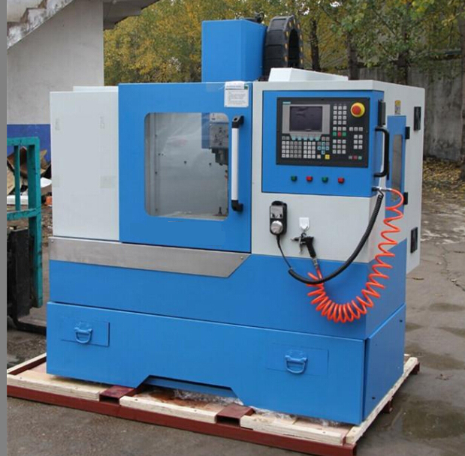

NO. | ITEM |  |  |  |  | Specification
1 | Table size L(mm)×W(mm) |  |  |  |  | 690×210
2 | T slot QTY /width/center distance(mm) |  |  |  |  | 3-16-63
3 | Maximum load(KG) |  |  |  |  | 100
4 | X travel (mm) |  |  |  |  | 330
5 | Y travel (mm) |  |  |  |  | 220
6 | Z travel (mm) |  |  |  |  | 320
7 | Spindle nose to table (mm) |  |  |  |  | 90-410
8 | Spindle center to column (mm) |  |  |  |  | 280
9 | Spindle taper |  |  |  |  | BT30
10 | Max. spindle speed (Rpm) |  |  |  |  | 10000
11 | Main motor （kW） |  |  |  |  | 2.2
12 | Feed motor | X torque（N.M） |  |  |  | 3.3
12 | Feed motor | Y torque（N.M） |  |  |  | 4
12 | Feed motor | Ztorque（N.M） |  |  |  | 5
12 | Feed motor | Max.install size |  |  | X | Square 90×90diameter φ80
12 | Feed motor |  |  |  | YZ | Square 110×110diameter φ95
13 | Rapid moving speed (m/min.） |  |  |  |  | 10
14 | Cutting speed （mm/min） |  |  |  |  | 1-4000
15 | Ball screw （diametermm/pitch ）mm |  |  |  |  | 20/5
16 | Linear guide way width（ mm） |  |  |  |  | 20
17 | Accuracy |  | Positioning accuracy (mm) |  |  | 0.02
17 |  |  | Repeatability accuracy (mm) |  |  | 0.01
18 | Tool changer |  | Funnel type (optional ) BT30 |  |  | 6
18 |  |  | Tool changing time (s) |  |  | 8
19 | Air pressure Mpa |  |  |  |  | 0.6
20 | Machine weight (kg) |  |  | Frame |  | 360
20 |  |  |  | Complete machine |  | 700
21 | Machine overall size :  L(mm)×W(mm)×H(mm) |  |  | Frame |  | 720×860×1160
21 |  |  |  | Complete machine |  | 1200×1100×2000

Vertical cnc milling machine VMC ACCUMAX-SE
Able to mill steel, copper, aluminum, wood and plastic
Taiwan spindle, taiwan linear guide ways
Complete machine: standard with external handwheel ,tri-colour lights,lubrication,coolant system.
Complete machine standard with RS232 interface.
Frame is with lubrication, without controller, without any electrical parts.

Tool
Suggested max tool length(BT30):200mm
Suggested max tool weight(BT30):5kg
Suggested max tool diameter(BT30):16mm

ATC(automatic tool changer)
Standard:funnel type tool changer(BT30,8 tools)
Optional:manipulator tool changer(different price)

Controller
Stnadard:GSK218M or KND1000M2 controller (with rigid tappering fuction)
Optional:Siemens 808D control panel with servo motor and servo driver made in China

Motor
When machine is ATC,spindle motor is servo motor,2.2KW,torque 14NM
When machine is withour ATC,spindle motor is serve motor,2.2Kw,torque 15.5NM
X,Y,Z axes are all servo motors

Accessories
Complete machine is with standard accessories:1 pc tool holder,1 pc pull stud,1 set collects, 1 pc spanner, 1 pc direct screwdriver, 1 pc Philips screwdriver.

Power
Please inform power voltage and current,if transformer is needed price would be different.

